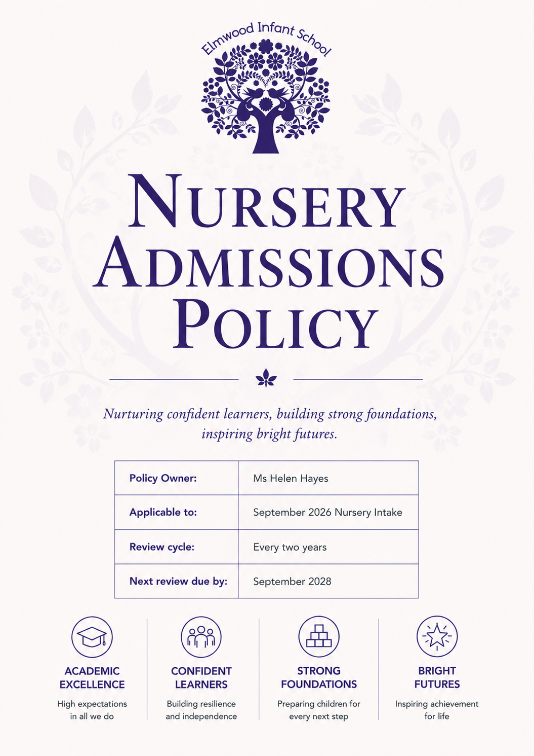

- Introduction
Elmwood Infant School is a community school for children aged 3–7 located in Croydon. The school provides nursery education for children aged 3–4 and offers both 15-hour part time and 30-hour full time funded nursery places. These places support early development, promoting confidence, social skills, and a secure transition into Reception.
This policy sets out how nursery places are allocated for the September 2026 intake, following Croydon Local Authority’s community school admissions arrangements.
Please note: Attendance at Elmwood Nursery does not guarantee a reception place. Reception admissions must be made via Croydon Council.
- How Applications for September 2026 Will Be Enrolled
Children eligible for the September 2026 intake are those who turn three on or before 31 August 2026.
All applications received by the deadline are processed in accordance with the oversubscription criteria in Section 4.
2.1 Eligibility for September 2026
Children are eligible for a September 2026 place if they turn three on or before 31 August 2026.
- Nursery Provision
3.1 Funding Options for September 2026
Families may apply for:
• 15-hour part time funded places
• 30-hour full time places (subject to confirming eligibility via a valid 30-hour code)
Where parental preference for a specific session pattern exceeds availability, places are allocated according to the admissions criteria in Section 4.
3.2 Part Time 15-Hour Provision
Elmwood offers two attendance patterns:
Option 1:
• Monday full day (8:45–3:15)
• Tuesday full day (8:45–3:15)
• Wednesday morning (8:45–11:45)
Option 2:
• Wednesday afternoon (12:15–3:15)
• Thursday full day (8:45–3:15)
• Friday full day (8:45–3:15)
Please note: Parental pattern preference is considered but cannot be guaranteed.
Option 3 (discretionary offer):
• Monday – Friday mornings only, 8:45–11:45 (15 hours total)
Option 3 may be offered at the school’s discretion only where all other part time patterns are full and where pupil numbers, staffing, and organisational circumstances allow. The availability of this option is reviewed annually and is not guaranteed in any academic year.
Parental preference for Option 3 may be considered where it is available; however, there is no entitlement to this pattern, and it will only be offered where it supports the effective organisation of the Nursery and the best interests of all children.
3.3 Full Time 30-Hour Provision
Eligible families may apply for a full-time place (Monday–Friday, 8:45–3:15).
A valid 30-hour code must be submitted before allocation.
3.4 Conditions for 30-Hour (Full Time) Places and Suitability of Hours
• Funding dependency – Full time (30-hour) places at Elmwood are contingent on a valid 30-hour eligibility code and the family’s continued entitlement to the extended entitlement. Parents/carers must provide the code by the school’s stated deadline and reconfirm eligibility each term in line with national guidance. If the 30-hour funding lapses, expires, or is withdrawn, the full time place may be revoked and the child will ordinarily revert to a 15-hour universal place, subject to availability and transition arrangements.
• Best interests and suitability of hours – In line with EYFS principles and the child centred approach, where full time attendance is not in a child’s best interests (for example, where the extended hours prove too demanding for the child’s wellbeing, development or settling), the school may recommend a 15-hour attendance pattern. This decision will be made in partnership with parents/carers, based on observations and professional judgement, and kept under review with clear next steps.
• Notice and transition – Where any change to hours is required (due to funding or suitability), the school will provide reasonable notice and a planned transition, ensuring continuity of care and learning.
4. Oversubscription Criteria
If more applications are received than places available, the following priority order applies:
- Looked-after and previously looked-after children.
- Children with exceptional medical/social needs.
- Siblings attending Elmwood Infant School at the time of admission.
- Children of staff (per LA criteria).
- Distance – straight-line measurement following Croydon rules.
Distance is the tie breaker for all categories.
- Updated Application Procedure
Parents applying for a Nursery place for September 2026 must complete an Elmwood Nursery Application Form and submit required documentation directly to the school office.
5.1 Required Documentation
Parents/carers must provide:
• Child’s full birth certificate
• Proof of home address (council tax letter, mortgage agreement, or tenancy agreement)
• Names of all adults with parental responsibility
• Details of authorised adults allowed to collect the child
• At least two emergency contacts (as part of safeguarding requirements)
• Information on whether the child is a looked-after child
• Any relevant medical information, including allergies, health conditions, or GP details
• Any known SEND information (used only to plan support; not to determine priority unless linked to an EHCP)
• Dietary requirements (allergies, intolerances, cultural needs)
• Optional equality monitoring information (language, ethnicity, religion)
These requirements are part of the school’s duty to safeguard children and ensure appropriate care under EYFS and child protection regulations.
5.2 Data Protection and Privacy
Elmwood Infant School is the Data Controller under UK GDPR. Only data necessary for admissions, safeguarding, education, and statutory duties will be collected and processed.
A link to the school’s full Privacy Notice will be provided with the application pack (parents sign separately).
6. Allocation of Session Types
If demand exceeds availability for:
• a specific part time pattern, or
• 30 hour full time places,
allocations will follow Section 4 oversubscription criteria.
A valid 30 hour eligibility code is required before a full time place can be confirmed.
7. Waiting List
A waiting list is maintained in oversubscription criteria order. It is reordered each time a new application is received.
8. In-Year Admissions
If places become available after September, the school may admit children mid-year. Applications must be made directly to the school.
9. Transition and Induction
Elmwood Infant School is committed to ensuring that all children experience a smooth and positive transition into Nursery. A well-planned induction supports children’s emotional security, confidence and readiness for learning. Transition arrangements for new Nursery starters include:
• Welcome Meeting – Parents and carers are invited to meet with staff to learn about the Nursery environment, daily routines, expectations, and how learning is supported in the early years. The welcome meeting also introduces families to key school procedures such as drop off and collection routines, lunchtime arrangements, communication systems and other important aspects of school life.
• Stay and play session – Children and families attend introductory sessions in the Nursery classroom, giving children the opportunity to explore the setting and begin forming relationships with staff in a familiar and supportive setting.
• Home visits – Before starting, each child receives a home visit from members of the Nursery team. Home visits help staff build strong relationships, understand the child’s needs and interests, and support a smooth and emotionally secure start.
• Staggered start arrangements – Children begin Nursery in small groups over several days, allowing staff to give each child additional support as they settle and ensuring a calm and positive beginning to their school experience.
Review of Policy
Reviewed every two years by the Headteacher and governing body.

