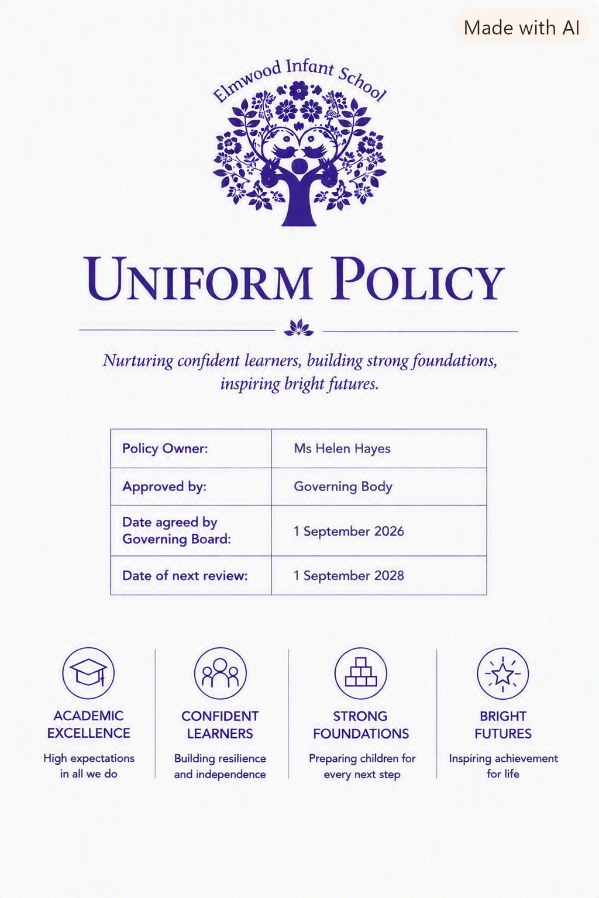
Contents
1. Aims 1
2. Our school’s legal duties under the Equality Act 2010 1
3. Limiting the cost of school uniform 2
4. Expectations for school uniform 3
5. Expectations for our school community 4
6. Monitoring arrangements 6
7. Links to other policies 6

1. Aims
This policy aims to:
- Set out our approach to requiring a uniform that is of reasonable cost and offers the best value for money for all parents and carers
- Explain how we will avoid discrimination in line with our legal duties under the Equality Act 2010
- Clarify our expectations for school uniform

2. Our school’s legal duties under the Equality Act 2010
The Equality Act 2010 prohibits discrimination against an individual based on the protected characteristics, which include: age, sex, sexual orientation, disability, race, religion or belief, pregnancy and maternity, and gender reassignment.
To avoid discrimination, our school will:
- Avoid listing uniform items based on sex, to give all pupils the opportunity to wear the uniform they feel most comfortable in
- Make sure that our uniform costs the same for all pupils
- Allow all pupils to have long hair, although we reserve the right to ask that long hair be tied back
- Allow all pupils to style their hair in a way that is appropriate for school, and makes them feel most comfortable
- Allow pupils to request changes to swimwear for religious reasons, or if they are experiencing discomfort
- Allow pupils to wear headscarves and/or other religious garments
- Allow pupils with sensory or physical needs to make reasonable adaptations to their uniform, depending on their specific needs
- Allow for reasonable adaptations to our policy on the grounds of equality by asking pupils or their parents/carers to contact the school office (office@elmwoodinfants.co.uk). The office team will answer questions about the policy and respond to any requests. All requests will be considered on a case-by-case basis.

3. Limiting the cost of school uniform
Elmwood Infant School is committed to ensuring that our school uniform is affordable for all families, in line with statutory guidance from the Department for Education (DfE).
We recognise that items with distinctive characteristics (such as branded items or items requiring a school logo) can only be purchased from limited retailers. To support families and keep costs down, all branded items at Elmwood Infant School are optional, and suitable unbranded alternatives may be worn.
We will make sure our uniform:
- Is available at a reasonable cost
- Provides the best value for money for parents and carers
We will do this by:
- Following the statutory limit for compulsory branded items (Elmwood requires zero compulsory branded items)
- Carefully considering whether any items with distinctive characteristics are necessary, and limiting these wherever possible
- Allowing families to choose cheaper alternatives, such as unbranded jumpers or cardigans
- Avoiding specific requirements for coats, bags and shoes/trainers that pupils can also wear outside school
- Avoiding different uniform requirements for different year groups, classes or houses
- Avoiding different uniform requirements for extra-curricular activities
- Avoiding requiring different branded items at different times of the year
- Considering alternative ways to identify pupils for events or competitions (e.g., posters or badges)
- Loaning branded items for special events or competitions where needed
- Making sure second-hand uniform is available in a timely manner for current and prospective families, and publishing this information on our website
- Avoiding frequent changes to uniform specifications and minimising any financial impact on families
- Consulting with parents/carers and pupils on any significant proposed changes to the uniform policy
- Avoiding single-supplier contracts so that generic items can be purchased from a wide range of retailers
- Continuing to review this policy to ensure uniform remains affordable and offers good value for money

4. Expectations for school uniform
4.1 Our school’s uniform
At Elmwood Infant School, all branded items are optional. Families may choose to purchase branded items if they wish, but suitable unbranded alternatives are always permitted. Our uniform is designed to be simple, affordable and practical for young children.
Uniform expectations (all pupils):
Tops
- White or light blue polo shirt
- White or blue school shirt/blouse (open-neck or shirt type)
- Navy blue jumper or cardigan (optional branded sweatshirt/ cardigan available)
Bottoms
- Grey trousers, shorts, skirt or tunic
- Blue and white checked dress (summer)
Socks/Tights
- Plain white, navy, grey or black socks/ tights
Footwear & Coats
- Sensible black or dark blue shoes
- Sensible school-type coat (plain, any colour)
- Wellington boots may be worn by EYFS pupils in wet weather or for outdoor learning. Pupils should bring school shoes to change into when indoors.
PE Kit
- Navy blue or black shorts or jogging bottoms
- Plain yellow t-shirt or optional school logo t-shirt
- Trainers for all PE activities (indoor and outdoor)
Hair & Jewellery
- Long hair may be worn by any pupil but must be tied back for safety
- Pupils may style their hair in a way that is appropriate for school and makes them feel comfortable
- No jewellery except small stud earrings for pupils with pierced ears
Modesty & Fit
- Clothing should be comfortable, fit for purpose and allow pupils to move safely
- Skirts, dresses and shorts should be of a modest length suitable for active play

Bags
- Any sensible school-type bag may be used
- A school book bag (£4.50) is available from the school office and is highly recommended to safely store reading books.
Seasonal items
- Summer dresses may be worn in warmer months
- No seasonal branded items are required at any time of year
Loaning/Gifting
- The school may loan branded items for special events or competitions. Pupils may wear a suitable alternative if they prefer or if the loaned item is not suitable.
4.2 Where to purchase or acquire it
Parents and carers can purchase school uniform items from a wide range of high-street retailers. Elmwood Infant School does not require any compulsory branded items, so families are free to choose affordable, generic alternatives.
Optional branded sweatshirts, PE T-shirts and other branded items are available from:
Hewitts of Croydon Church Street, Croydon Website: www.hewittsofcroydon.com
School book bags (£4.50) are available from the school office.

Second-hand uniform
To support families and reduce costs, second-hand uniform is made available in a timely and discreet manner:
- Termly second-hand uniform sales are held at school
- Dates are shared with families in advance, including for new starters
- Families can request second-hand items discreetly via the school office at any time during the year
Information about second-hand uniform availability is published on the school website so that current and prospective parents/carers know how to access items before the start of the school year.

5. Expectations for our school community
5.1 Pupils
Pupils are expected to always wear the correct uniform (other than specified non-school-uniform days) while:
- On the school premises
- Travelling to and from school
- At out-of-school events or on trips organised by the school, or where they are representing the school (if required)
Pupils who wish to request an amendment to the uniform policy in relation to their protected characteristics should contact the school office (office@elmwoodinfants.co.uk). Requests will be considered on a case-by-case basis.
5.2 Parents and carers
Parents and carers are expected to make sure their child has the correct uniform and PE kit, and that every item is:
- Clean
- Clearly labelled with the child’s name
- In good condition
Parents/carers who wish to request an amendment to the uniform policy in relation to their child’s protected characteristics or the cost of uniform should contact the school office (office@elmwoodinfants.co.uk).
Parents/carers are expected to raise any complaints or concerns about school uniform in a timely and reasonable manner, in line with the school’s complaints policy.
Disputes about the cost of uniform will be:
- Resolved locally
- Managed in accordance with the school’s complaints policy
The school will work closely with parents/carers to reach a mutually acceptable outcome.
5.3 Staff
Staff will monitor pupils to ensure they are wearing the correct uniform. Pupils and families who are not complying with the uniform policy will be given the opportunity to put things right, but staff will follow up with the headteacher if the situation does not improve.
Ongoing breaches of the uniform policy will be dealt with in line with the school’s behaviour policy.
Where financial hardship is suspected, staff will take a mindful and considerate approach. Pupils will not miss classroom learning because of a sanction related to uniform, in line with statutory guidance.
5.4 Governors
The governing board will review this policy and ensure that it:
- Is appropriate for the school’s context
- Is implemented fairly across the school
- Takes into account the views of parents/carers and pupils
- Offers a uniform that is appropriate, practical and safe for all pupils
The governing board will also ensure that uniform supplier arrangements prioritise cost and value for money, for example by avoiding single-supplier contracts and re-tendering contracts at least every five years.

6. Monitoring arrangements
This policy will be reviewed every two years by the headteacher. At every review, it will be approved by the full governing board.

7. Links to other policies
This policy is linked to our:
- Behaviour policy
- Equality information and objectives statement
- Anti-bullying policy
- Complaints policy

