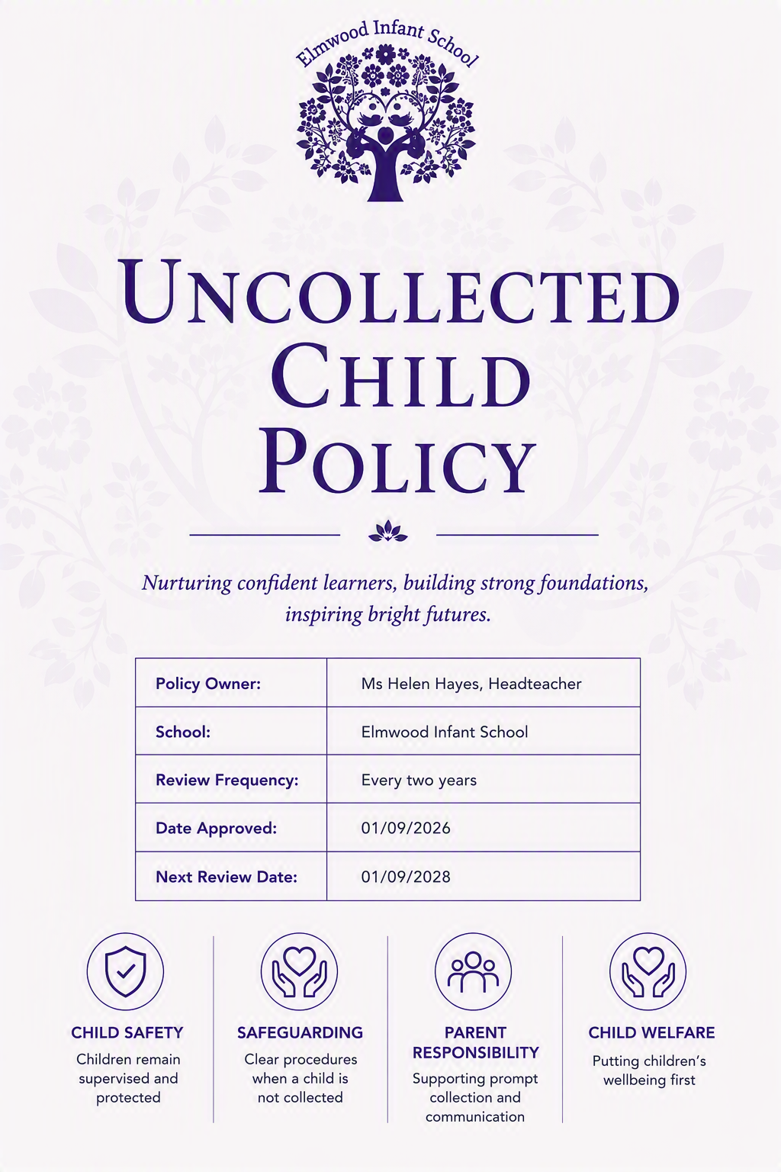

Policy Statement
At Elmwood Infant School, the safety and welfare of our children is our highest priority.
We recognise that from time-to-time unforeseen circumstances may prevent a parent, carer or authorised adult from collecting a child at the end of the school day. This policy sets out the procedures the school will follow to ensure that all children remain safe, supervised and supported until suitable collection arrangements can be made.
The school expects all children to be collected promptly at the end of the school day. Regular late collection can cause distress for children and places additional demands on school staff. Repeated late collection may be treated as a safeguarding concern and will be monitored by the school. This approach is consistent with common safeguarding practice in uncollected child policies.

Collection Arrangements
- The school day ends at 3.15pm.
- Children must be collected from their classroom by a parent, carer or authorised person.
- For safeguarding reasons, children will only be released to an adult who is 16 years of age or over.
- Children will not be released to an unknown adult unless prior permission has been received from a parent or carer and suitable identification has been provided where necessary.
- If collection arrangements change during the day, parents and carers must notify the school office as soon as possible.
- Under no circumstances will a child be permitted to leave the school site unaccompanied.

Emergency Contact Details
Parents and carers must ensure that:
- The school holds current telephone numbers for all parents and carers.
- A minimum of two emergency contacts are provided.
- Emergency contact details are kept up to date at all times.
Failure to maintain up-to-date contact information may delay the school's ability to reunite a child with their family in an emergency.

If You Know You Will Be Late
Parents and carers must contact the school office as soon as possible if they believe they may be delayed.
If a parent knows in advance that they will be unable to collect their child on time, they should make alternative collection arrangements.
Where spaces are available, parents may be able to book an ad hoc place in the school's After School Club.
If a child requires a place in After School Club because they have not been collected at the end of the school day, the parent or carer will be charged in line with the school's After School Club fees.
The school does not provide free childcare for late collection.

Procedure for Uncollected Children

By 3.15pm
Children will remain with their class teacher while normal collection arrangements are completed.

By 3.30pm
Any child who has not been collected by 3.30pm will be taken to the school office.
The child will remain supervised by school staff in a safe and caring environment.
Staff will:
- Check whether alternative collection arrangements have been communicated.
- Attempt to contact parents and carers using all available telephone numbers.
- Contact emergency contacts where parents and carers cannot be reached.
- Keep a record of all contact attempts and actions taken.
The Designated Safeguarding Lead (DSL) or a member of the Senior Leadership Team will be informed.

If a Child Remains Uncollected
If all reasonable attempts to contact parents, carers and emergency contacts have been unsuccessful, the Designated Safeguarding Lead (DSL) or a member of the Senior Leadership Team will be informed immediately.
If a child remains uncollected one hour after the end of the school day (4.15pm) and the school has been unable to make contact with a parent, carer or emergency contact, the DSL will contact Children's Social Care for advice and support.
Where there are immediate concerns for the child's safety or welfare, the school may also contact the police.
The child will remain safely supervised by school staff until they are collected by a parent, carer or other authorised adult, or until alternative arrangements have been agreed with Children's Social Care or the police.

Repeated Late Collection
Where a child is collected late on a regular basis, the school will:
- Discuss the matter with parents or carers.
- Offer support where appropriate.
- Monitor the situation.
- Consider whether the pattern of late collection presents a safeguarding concern.
Repeated late collection may result in involvement from the school's safeguarding team and, where necessary, referral to external services.

Responsibilities of Parents and Carers
Parents and carers are expected to:
- Collect their child promptly at 3.15pm.
- Inform the school immediately if they are delayed.
- Keep emergency contact information up to date.
- Ensure alternative collection arrangements are communicated clearly to the school.
- Arrange After School Club provision where they know in advance that they will be unable to collect their child on time.

Monitoring and Review
This policy will be reviewed regularly by the Headteacher and Governing Board to ensure it remains effective and reflects current safeguarding requirements.

