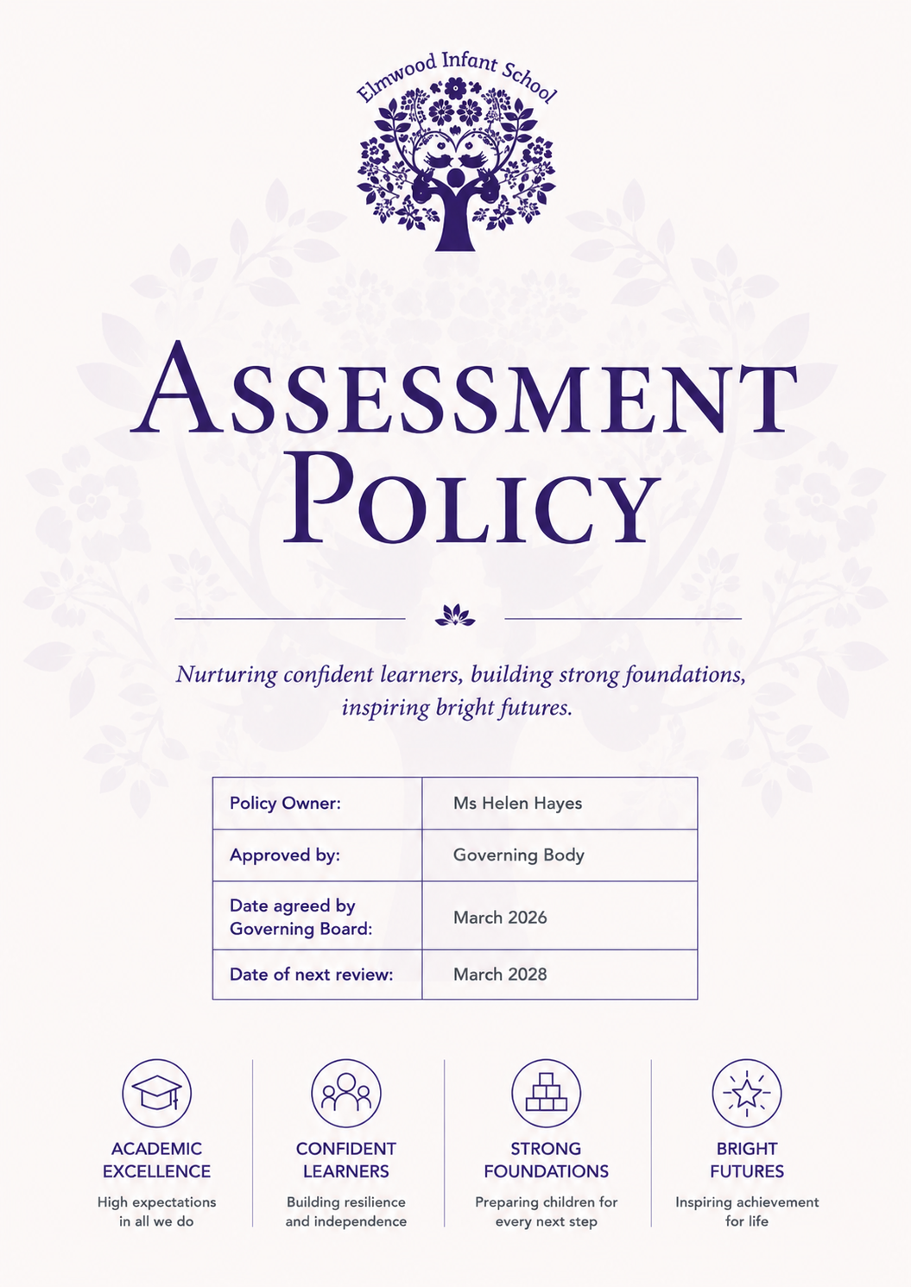

2. Statutory Assessments in EYFS and Key Stage 1

2.1 Reception Baseline Assessment (RBA)
All Reception children complete the Reception Baseline Assessment within their first six weeks in school. The RBA is a short, interactive task assessing early literacy, communication, language and mathematics. It provides a starting point for measuring cohort progress from Reception to the end of KS2.
The RBA is not used to judge individual children or to evaluate EYFS provision. It is not a pass/fail assessment and gives teachers helpful one-to-one time early in the year.

2.2 Early Years Foundation Stage (EYFS)
At the end of Reception, all pupils must be assessed against the Early Years Foundation Stage Profile (EYFSP). This statutory assessment is completed in the final term of the school year in which the child turns five.
The EYFSP provides a summative, holistic picture of each child’s development at the end of the EYFS. Teachers assess children’s attainment in relation to the 17 Early Learning Goals (ELGs) across the seven areas of learning, as set out in the statutory EYFS framework.
Judgements are based on a broad range of evidence, including observations, children’s work, their responses in play and adult-led activities, and professional discussions with staff who know the child well. This reflects the principle that accurate assessment comes from the teacher’s secure knowledge of the child and what they can consistently demonstrate.
The ELGs describe the expected level of development for the end of Reception; children are assessed as either ‘expected’ or ‘emerging’ for each goal. The Profile supports a smooth transition into Year 1 by giving receiving teachers clear information about each child’s strengths and areas where further support may be needed

2.3 Phonics Screening Check
At the end of Year 1, pupils complete the statutory phonics screening check, which is designed to confirm whether they have secured age-appropriate phonic decoding skills.
The check consists of 40 words, divided into two sections, containing a mixture of real words and pseudo-words (also known as alien words). Pseudo-words are used to assess whether children can apply their phonics knowledge to decode unfamiliar combinations of sounds, and are accompanied by a picture of an imaginary creature to ensure children are not trying to attach meaning to them.
The check is administered one-to-one by a familiar adult in a calm setting and usually takes only a few minutes. Results help teachers identify any children who may need additional targeted phonics support so that they do not fall behind in early reading.
Children who do not meet the expected standard in Year 1 receive extra support and re-take the check in the summer term of Year 2.

3. Moderation
Teachers’ moderate assessment judgements continually to ensure consistency and accuracy. This includes:
- Internal moderation within year groups and across EYFS and KS1 teams.
- Cross-school moderation with colleagues in the local area.
- Local authority moderation, working alongside Croydon LA advisers to quality-assure judgements.
This process aligns with national expectations for EYFS and KS1 teacher assessment.

4. Phonics Assessment

4.1 Systematic Synthetic Phonics – Little Wandle
Elmwood Infant School follows Little Wandle Letters and Sounds Revised, a fully validated systematic synthetic phonics (SSP) programme. Weekly phonics planning follows a consistent, easy-to-use structure with assessment points built into each block of teaching, enabling teachers to monitor progress closely.
Children are taught phonics daily in Reception and Year 1, moving systematically through Phases 2–5 to build secure and accurate decoding. Daily ‘keep-up’ and ‘catch-up’ sessions provide additional practice for any children who need support to maintain pace with the programme.

4.2 Half-termly Phonics Assessments
Little Wandle includes formal assessments every half term at the end of each teaching block. These assessments allow teachers to check:
- grapheme–phoneme correspondence (GPC) recognition
- blending for reading
- segmenting for spelling
- reading of words containing new and previously taught GPCs
- ability to read simple and more complex words accurately and automatically

4.3 Rapid Catch-Up Assessment (Every Three Weeks)
For pupils receiving Little Wandle Rapid Catch-Up, progress is reviewed every three weeks to ensure that intervention is tightly targeted and effective.
These short-cycle assessments ensure children who have fallen behind make rapid progress and close gaps swiftly, matching the main programme’s content but delivered in smaller steps with more repetition.

5. Approaches to Assessment
Elmwood Infant School uses a broad range of assessment practices, based on the principle that the most accurate assessment comes from high-quality interactions with children and from seeing their work over time.

5.1 Assessment for Learning (formative)
Teachers regularly review pupils’ work in the core subjects and across the foundation subjects to see how well they are applying the knowledge and skills taught in class. This helps teachers identify misconceptions, monitor progress over time and plan next steps that build securely on each child’s learning.
This includes:
- responsive feedback
- questioning and discussion
- observation of play and learning behaviours
- review of work in books, in conjunction with the school’s marking policy
- phonics assessments within Little Wandle weekly review sessions

5.2 Assessment of Learning (summative)

Termly Summative Assessments
In addition to the statutory assessments outlined in Section 2, the school conducts termly summative assessments.
Three times a year, teachers assess each child’s learning in reading, writing, maths and the wider curriculum. In EYFS, this includes all areas of learning, and in KS1 it focuses on reading, writing and maths. These assessments give a clear picture of each child’s progress and highlight any areas where they may need additional support.
Teachers review children’s progress by looking closely at the learning they produce in class over time. This is not a formal test for pupils. Instead, teachers use pupils’ everyday work, alongside observations and short, informal checks, to understand how well each child is progressing. This helps us see what children are secure in, where extra practice may be needed, and what support or challenge should be planned next so that every child continues to move forward in their learning.
Assessment information is uploaded onto Sonar Tracker, allowing teachers to identify whether pupils are working at, above or below age-related expectations. This ensures that any concerns are spotted quickly and that timely support is put in place.
These assessments also help us recognise and celebrate the strong progress pupils make throughout the year. Outcomes from these termly reviews are shared with parents during Parents’ Evening, and a full summary is included in end-of-year school reports.

5.3 Assessment as Learning
Children are encouraged to talk about their learning, reflect on their work and respond to next steps in an age-appropriate way. This supports the development of independence, ownership of learning and early metacognitive skills.
Teachers also build regular opportunities for children to think about their thinking through:
- short recapping activities where pupils revisit previous learning to strengthen memory and understanding
- fun, low-stakes quiz games that help children check what they remember in a relaxed, enjoyable way
- quick recall challenges (such as flashcards, oral questions or matching games) that help pupils recognise what they know well and what they need to revisit
These approaches help children become more aware of their learning, build confidence and support strong long-term retention, while ensuring assessment feels positive, supportive and age-appropriate.

6. Assessments for Children Educated Outside Their Normal Age Group
Some children may be educated outside their chronological year group, including summer-born pupils whose entry to school has been delayed. Such requests are considered individually by the admissions authority, taking into account the child’s needs and the Headteacher’s view.
Statutory assessments are completed when the child reaches the end of the phase or year group they are actually being taught in, not according to their age.
For example, a child who starts Reception a year later will complete the EYFS Profile at the end of their Reception year. The same principle applies across all statutory assessments: pupils are assessed when they complete the relevant key stage or programme of study, even if they are older or younger than their classmates.
This ensures all assessments reflect the curriculum a child has experienced and remain consistent with national expectations.

7. Using Assessment to Inform Provision and Support
Assessment information is used to plan high-quality provision across the school. Teachers and leaders use assessment outcomes to:
- identify learning gaps and plan targeted support
- adapt classroom teaching to ensure pupils keep up
- inform intervention groups and additional adult support
- contribute to the school’s provision mapping for all pupils, including those with SEND or additional needs
- review progress and attainment at regular pupil progress meetings, led by the Senior Leadership Team (SLT), to ensure every child remains on track
- update provision maps termly so that support is precisely matched to pupils’ needs and adjusted promptly where required
This structured approach ensures assessment leads directly to improved outcomes for every child and that the right support is in place at the right time.

8. Assessment and SEND
For pupils with SEND, assessment plays a crucial role in identifying strengths, barriers to learning and the most effective next steps. Teachers adapt assessment approaches where appropriate, following guidance from the SENDCO, to ensure pupils can demonstrate what they know and can do.
Assessment for pupils with SEND follows the graduated approach of assess–plan–do–review, ensuring that support is responsive and continually refined. At Elmwood Infant School, we prioritise early and accurate identification of need. Ongoing assessment informs planning, shapes targeted support and enables regular review of its impact. This continuous cycle helps reduce barriers to learning and ensures pupils with SEND receive timely, personalised and effective support.
For pupils with an Education, Health and Care Plan (EHCP), assessment information directly informs the setting and reviewing of EHCP outcomes. Staff work with the SENDCO and external professionals to break EHCP targets into small, achievable steps and track progress as part of each child's personalised support plan.
Some pupils may be assessed using pre-key stage standards or the engagement model where they are not yet engaging in subject-specific learning. Because progress for pupils with SEND is not always linear, the school takes an individualised approach that recognises small steps of progress, generalisation of skills, increasing independence and improved engagement as meaningful indicators of development.
Elmwood Infant School is committed to strong, inclusive practice for all pupils with SEND. We ensure needs are identified accurately and early, and that leaders and staff work together to adapt the curriculum and teaching so that every child can access learning successfully. Assessment information is used proactively to guide interventions, reduce barriers and shape individual support.
We make effective use of specialist advice where needed, and we work closely with parents and pupils so their views, experiences and aspirations inform decisions about support. This collaborative, whole-school approach ensures pupils with SEND are included fully in school life and receive the help they need to thrive.
Regular assessment contributes to SEND support plans, provision mapping and ongoing reviews, ensuring the right support is in place and adjusted promptly. This approach ensures assessment for pupils with SEND is precise, personalised and promotes positive academic, social and emotional outcomes.

9. Reporting to Parents
The school communicates regularly with parents about progress. In addition to parents’ evenings and annual reports, staff contact parents whenever concerns arise to ensure early support and strong home–school partnership.

10. Recording and Storing Assessment Information (GDPR)
All assessment information is securely stored and processed in accordance with the school’s Data Protection Policy and GDPR. Access is restricted to staff who require it for their professional role.

11. Review of the Assessment Policy
This policy is reviewed annually by Senior Leadership and governors to ensure it remains aligned with statutory requirements, best practice and the needs of the school community.

