Elmwood Infant and Nursery School

Behaviour

Policy

Behaviour Policy
Updated Spring 2023
Article 28 ‘Every child has the right to an education’
Article 2 ‘Every child has the right to be treated equally and with respect’
Article 31 ‘Every child has the right to play in a safe environment’
Article 14 ‘Every child has the right to their own beliefs and opinions and to share them freely’
Article 12 ‘Every child has the right to be heard and listened to’

Elmwood Infant School & Nursery
Behaviour Policy
In line with; DFE guidance Behaviour in schools Advice for headteachers and school staff Sept 2022
Date Policy Reviewed | Autumn 2023
Review Date: | Autumn 2025

Introduction
Elmwood Infant School is a Rights Respecting School, based on the UNICEF Convention for the Rights of the Child. We believe that all children should grow up aware of these rights and respect these rights for themselves and for others. At Elmwood, we have wholly incorporated this into our ethos and aims. As a Right Respecting School, we believe that teaching children about their rights will promote positive behaviours and develop successful, responsible citizens for the future.

- We have the right to learn (Article 28)
- We have the right to be treated equally and with respect (Article 2)
- We have the right to play in a safe environment (Article 31)
- We have the right to be protected and feel safe (Article 19)
- We have the right to our own beliefs and opinions and to share them freely (Article 14)
- We have the right to be heard and listened to (Article 12)
- We have the right to choose our own friends and set up groups (Article 15)

At Elmwood Infant School, we believe good behaviour is based on mutual respect. This starts from the moment the child enters school in the way that adults interact with the children, children interact with adults and the way children interact with each other. Through our behaviour policy we aim to promote a positive learning environment in which each person is valued and respected for their cultural and linguistic backgrounds, gender, faith, class, ability, sexuality and age.

Aims
- To contribute to the ethos of the school.
- To ensure that the conduct of all members of the school community is consistent with the values of the school.
- To make Elmwood an interesting, enjoyable, safe, secure and caring environment for children’s learning.
- To develop and foster mutual respect between adults and children, children and children and children and adults and adults.
- To build up self-esteem and self-worth by developing positive abilities and attitudes.
- To provide a structure in which children, staff and families know what is expected of them and to work in partnerships with parents / carers to help children develop self-discipline and strategies to successfully manage their own behaviour and take responsibility for their actions.
- To ensure that children’s learning and progress is not interrupted due to another child’s inappropriate behaviour.
- To protect and respect the environment.
- To be listened to and to listen to others.

Key Principles of Behaviour Management

Being Inclusive
- Some individuals need more support than others in learning to respect the rights of others and to meet the school’s expectations of behaviour.
- We have a responsibility to teach social behaviour to all children.
- We should be clear with staff, pupils, parents/carers, governors about which expectations are non-negotiable.
- All pupils have the right to be educated no matter how challenging their behaviour.
- Dealing with challenging behaviour often helps us to find ways to improve our systems, processes and procedures. We should seek to adapt these to fit our diverse populations.

Being Positive
- Parents and carers need to be as fully involved as possible.
- We should have consistently high expectations of what is acceptable behaviour in our school and within the wider community and should seek to raise those expectations in partnership with staff, governors with pupils and parents/carers.
- We should recognise positive behaviour through positive reinforcement
- We should provide pupils with honest and sensitive feedback on their own learning and behaviour.

Being Assertive
We all have rights…..
- Teachers have the right to teach, pupils have the right to learn
- Pupils and staff have the right to feel safe in school
- Parents and carers have the right to feel welcome and to know their children work, play and learn in a friendly, safe and helpful school
- We should never tolerate violent, abusive or anti-social behaviour in the classroom or anywhere in school
……. but we also have responsibilities

Here are some examples:
To listen | To help
To expect the best from ourselves | To expect the best from each other
To discuss | To encourage
To be polite | To make time for others
To be on time | To help and understand each other
To help others feel included | To solve our problems in a fair manner
To be honest | To look after each other
To respect others | To work and play safely
To share equipment | To share time
To co-operate | To ask for help
To solve our problems using words and not aggression

Everyone in the school has rights and responsibilities. To help protect our rights and to encourage responsibility, we have class, school and playground charters. It is important that these expectations are discussed and referred to as part of behaviour management strategies. (See Appendix 1)

Each class charter is created by the children and staff within the class and everyone signs up to it, agreeing to respect the chosen rights for themselves and others.

Promoting Positive Behaviour

Whole school level – Elmwood is a Rights Respecting School
- All adults understand and demonstrate the school’s core beliefs about behaviour
- Assemblies are used to develop children’s social, emotional and behavioural skills.
- Positive behaviour in corridors, outside areas and dining hall is promoted and celebrated.
- Parents / carers are aware of and contribute to the school’s positive behaviour ethos.
- Clear systems are used for dealing with inappropriate behaviour.
- The school uses the language of ‘choice’ and ‘rights’ concerning behaviour
- The whole school community model controlled, respectful verbal and non-verbal behaviour and are polite to the children.
- Golden assembly is used to recognise children’s ability to demonstrate their understanding of their rights through their actions and choices.

Classroom level
- Teaching routinely incorporates activities designed to promote children’s social skills and emotional development.
- Lessons are planned to be interesting, appropriately challenging and differentiated.
- Appropriate behaviour is taught and reinforced on a regular basis.
- Children are taught the language of sharing and cooperation, rights, choice and consequences.
- Children are encouraged to identify their own and others’ strengths and to recognise and value the diversity within their classroom.
- All adults are to be aware of children with behaviour, emotional and social difficulties and may make adaptations to managing behaviour where necessary.
- There are school charters, class charters and rewards, devised through discussion and agreed with children, promoting positive social and learning behaviours, teaching children about their rights and ways to respect others rights. Rewards include: dojos, star charts, stickers, sharing achievements with members of staff, mentions in the ‘Golden Book’ and other systems designed to promote positive behaviour.
- Appropriate behaviour is quickly noticed and celebrated by adults and peers.
- There are clear systems, which are used across the school and understood by all, for dealing with inappropriate behaviour. These are adapted for individuals and classes as required.

Individual Child Level
- All children’s strengths are recognised and celebrated by the school community.
- Systems are in place for noticing and drawing attention to good or improved behaviour.
- There are systems which allow all children to achieve in class rewards and recognition in reward assemblies.
- Systems are in place for every child to develop resourcefulness, reflection, respect and to develop their understanding of personal responsibility for behaviour.
- Where a child has difficulties in developing or sustaining appropriate behaviour, there are systems which give additional support and attention. These include individual sticker charts, personal visual timetables, social stories, morning meet and greet, regular contact books with parents / carers, ELSA support and behaviour support plans.

Responding to the behaviour of children with SEND.
Behaviour will be considered in relation to a child’s SEND, although it does not follow that every incident of misbehaviour will be connected to their SEND. Where a child’s behaviour is linked to their SEND the graduated response will be used to assess, plan, do and review provision to support them meet the school’s behaviour expectations. Patterns of behaviour will be recorded for some children with SEND in an ABC chart.
Staff will anticipate likely triggers for challenging behaviours and put in place support to prevent these. Preventative measures will include; a calm, safe supportive environment, movement breaks, adjusted seating plans, distraction activities, rewards, an alternative learning space and training for staff in understanding conditions such as autism
When incidents occur staff will use behavioural support strategies based upon an individual’s needs, characteristics and preferences. The Nurture room, sensory room or a quiet space will be used to support a chid to regulate his/her emotions when an identified sensory overload has occurred. Verbal and non-verbal calming techniques will be used. When calm, children will be re-directed and praised for their engagement, for discussing their feelings and regaining self-control.

Dealing with Inappropriate Behaviour
Elmwood has agreed consequences for different stages of behaviour, which are followed consistently.
- Each child should be given a fresh start as soon as possible.
- A child should be given time to reflect and then apologise for poor behaviour choices.
- At no point do we issue ‘blanket sanctions’ for a class.

Step 1
(Talking to peers when an adult is talking, calling out answers instead of raising a hand, making silly comments to get attention, minor squabbles with peers)
- Most behavioural issues in the classroom and around the school are to be dealt with by the class teacher or the first adult who observes the behaviour or is informed of the incident.
- In the first instance staff are expected to use appropriate behaviour management strategies to deal with behaviour problems in their own class.
- The next steps should not be taken unless and until the child / children have been
- Spoken to about their behaviour by their class teacher / member of staff
- Moved within the classroom
- Supported in their learning
- Warned about the consequences of their behaviour
Step 2
(Actions that stop others from learning, rude language, aggressive behaviour, damage to school property, refusal to follow an instruction)
- If, following the class teacher’s own behaviour strategies, the child’s behaviour is deemed to be affecting their own and other children’s learning, they can be sent to a class within the year group for 10 minutes with their work. A sand timer should be used during this time to avoid children be removed from their classroom for long periods of time.
- If a child is sent from the classroom more than twice a week or if there is a serious incident, the class teacher should inform the child’s parents / carers.
- ABC charts will be used for some children to help identify triggers.

Step 3
(Inappropriate language, repeated misbehaviour for attention in class, aggressive behaviour towards others, biting, persistent disruption, racist comments / incident)
- A child may have privileges withdrawn, for example losing playtime or lunchtime play. The member of staff issuing the sanction must supervise the child / children and where serious incidents occur a Year Group Leader or member of SLT may supervise the children during this time.
- Incidents of a more serious nature will be recorded in CPOMs (biting, aggressive behaviour, disruption, racist comment / incidents for example).
- Where a child’s behaviour is causing concern, a meeting will be arranged with the class teacher and the child’s parents / carers, to review strategies to promote positive behaviours. Strategies will be agreed, implemented and monitored.
- If there are persistent ongoing concerns, a subsequent meeting will be called which will include a member of the Senior Leadership Team.
- Recognition of pupils’ difficulties will be supported by a Behaviour Support Plan, which will be drawn up in consultation with parents / carers and the pupil concerned. In the interest of fairness, the pupil will have opportunity to express his/her view or version of events.
- Risk assessments are completed for individual children whose behaviour is violent and / or unpredictable and may put students and staff at risk. Once completed risk assessments are shared with members of the SLT and staff directly involved in working with the child.
- Racial comments / incident must always be reported to a member of the SLT.

Step 4
Dangerous and extreme behaviour may, if all other avenues have been exhausted, result in the child being given an in-house suspension from class, a call to be collected or formal fixed term suspension. The school follows the guidelines set by the Department of Education for formal fixed term suspensions.

In the event of a serious incident that may affect the safety of other children, a member of the Senior Leadership Team must be immediately informed and they will attend immediately.

Suspensions
The school will follow all guidance outlined in the DfE (2017) Suspensions from maintained schools, academies and pupil referral units in England.

Suspension is a disciplinary sanction that the Headteacher will only use in response to serious breaches of the schools’ behaviour policy and expected Code of Conduct. When a pupil fails to comply with the expected Code of Conduct there is need to intervene promptly and effectively in order to keep the pupil within school wherever possible and to avoid the ultimate sanction of permanent suspension. Arrangements will be made for the school to provide and mark work during the periods of suspension.

The school also reserves the right to ban parents / carers or other visitors from the school premises if their behaviour towards staff, children or others adults is considered to be unacceptable particularly if they are:
- Verbally or physically aggressive
- A danger to themselves or others.

Please refer to our complaints policy for further information on this area.

Restrictive Practices (physical intervention)
Restrictive practice means “the implementation of any practice or practices that restrict an individual’s movement, liberty and/or freedom to act independently without coercion or consequence”.

In very rare situations, where a child is refusing to follow a reasonable instruction to stop their behaviour, the law allows staff to physically restrain a pupil using ‘reasonable’ force. Reasonable force may be used to prevent:
- harm being caused to themselves or another person
- damage to property, creating an unsafe environment
- an offence to be committed
- a child from leaving a room / area where to leave would cause damage or harm
- a pupil from behaving in a way that disrupts a school event, trip or visit,

Before any physical intervention, staff will use proactive, non-physical strategies and interventions to distract the child and diffuse the situation. Restrictive practice will only be used as a last resort and will use the minimum force for the minimum amount of time necessary. Those teachers who have undergone physical intervention training are therefore most likely to be called upon to physically restrain a pupil, should this ever be necessary. However, this does not remove the same power from any paid employee, should an occasion arise where physical intervention would be deemed necessary. Should a child ever be physically restrained, then the appropriate form will be filled in and the parent / carer of the child would be informed. (See Appendix 2) This point should only be reached when all possible options for giving the pupil time/space to regain self-control have been exhausted.

Confiscation of Inappropriate Items

There are two sets of legal provisions which enable school staff to confiscate items from pupils:
1. The general power to discipline enables a member of staff to confiscate, retain or dispose of a pupils’ property as a punishment. Staff are protected against liability for damage to, or loss of, any confiscated items provided they have acted lawfully and reasonably. The legislation does not describe what must be done with confiscated item.
2. Power to search without consent for ‘prohibited items’ including:

- Knives and weapons
- Alcohol
- Illegal drugs
- Stolen items
- Tobacco and cigarette pap
- Pornographic images
- Any article that has been or is likely to be used to commit an office, cause personal injury or damage to property
- Any item banned by the school rules which has been identified in the rules as an item which may be searched for

Weapons and knives and extreme or child pornography must be handed to the Police. Otherwise it is for the teacher to decide if and when to return an item, or whether to dispose of it.

Employed Staff Powers to Discipline Pupils
The Education and Inspections Act 2006 included, for the first time, a specific power for teachers to discipline pupils – for breaking a school rule, failure to follow instructions or other unacceptable behaviour. It applies at any time a pupil is in school or elsewhere under the charge of a teacher, including where a pupil is participating in an educational visit. The power also applies to other staff with responsibilities for controlling pupils, such as teaching assistants.

The Act also states schools’ discipline and behaviour policies may allow teachers to regulate the conduct of pupils when they are off school premises and not under the control of school staff.

Pupils’ Conduct Outside the School Gates – Teachers’ Powers

At Elmwood Infant School we may take action in cases of misbehaviour that takes place when pupils are away from the school premises and outside the jurisdiction of the School, for example travelling to or from school, during weekends and in the holidays. This will normally be where the conduct in question could have repercussions for the orderly running of the School, affects the welfare of a member or members of the School Community or a member of the public, or which brings the School into disrepute.

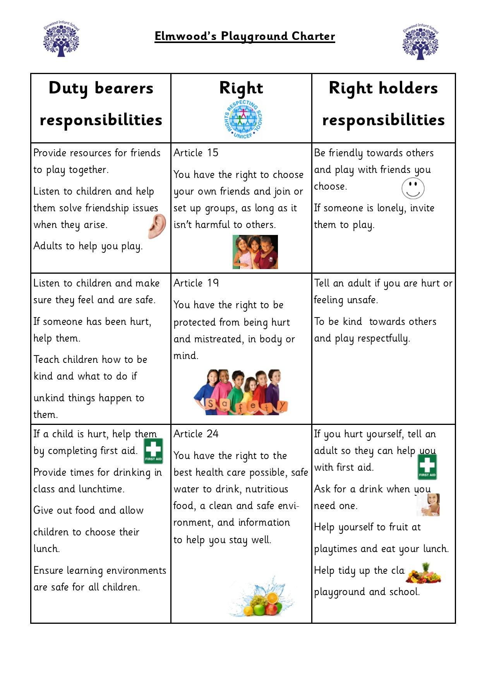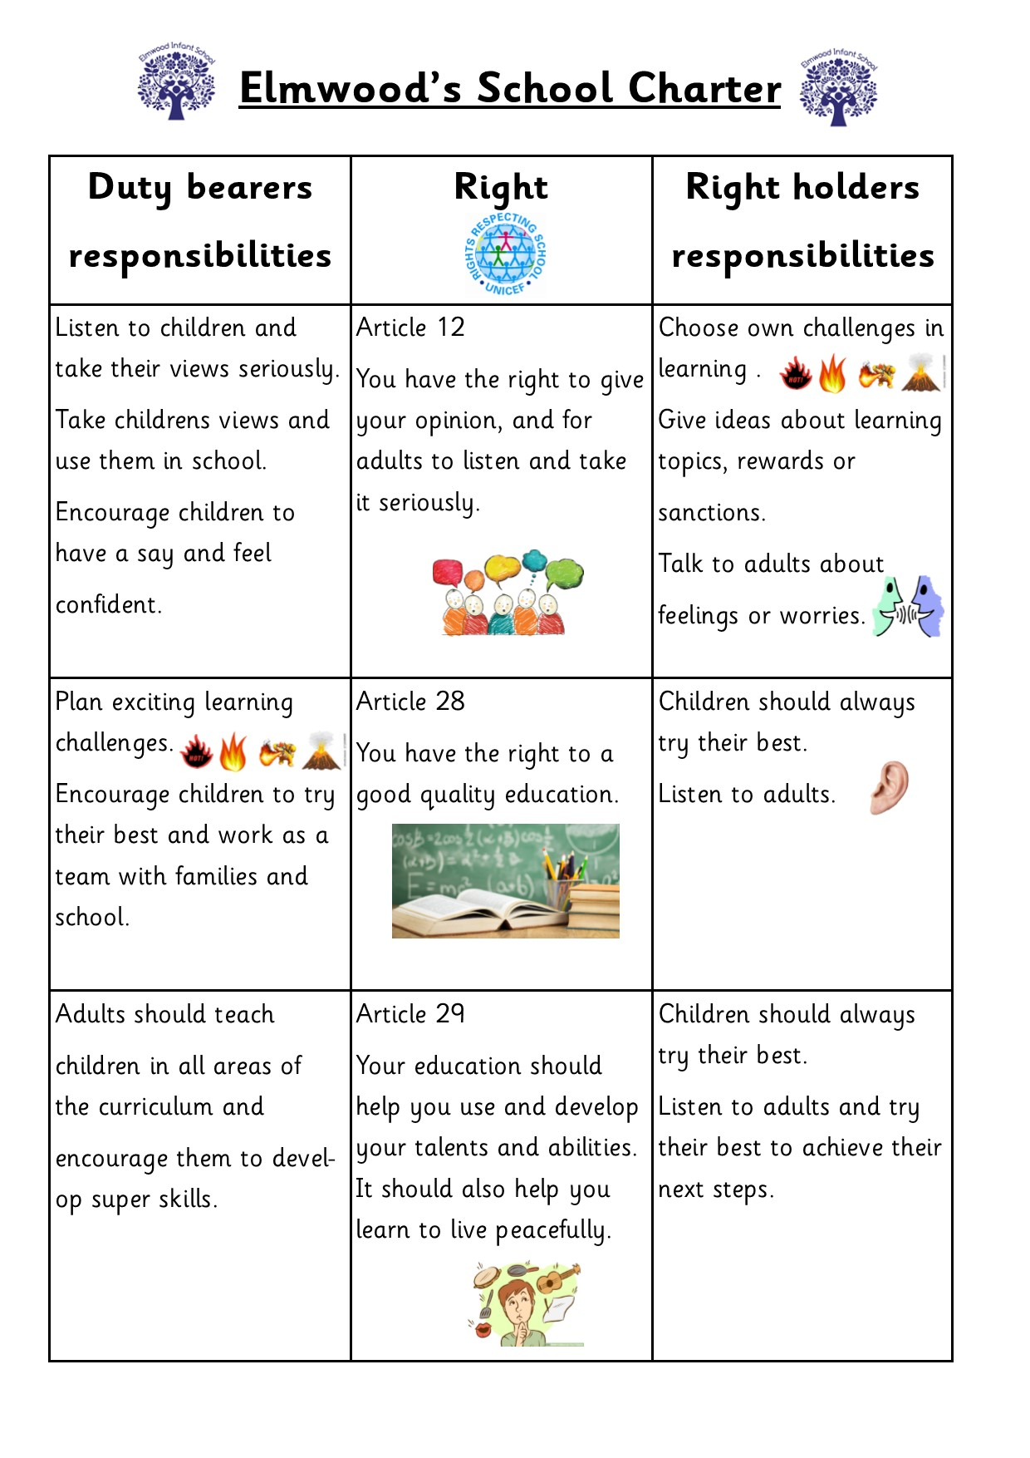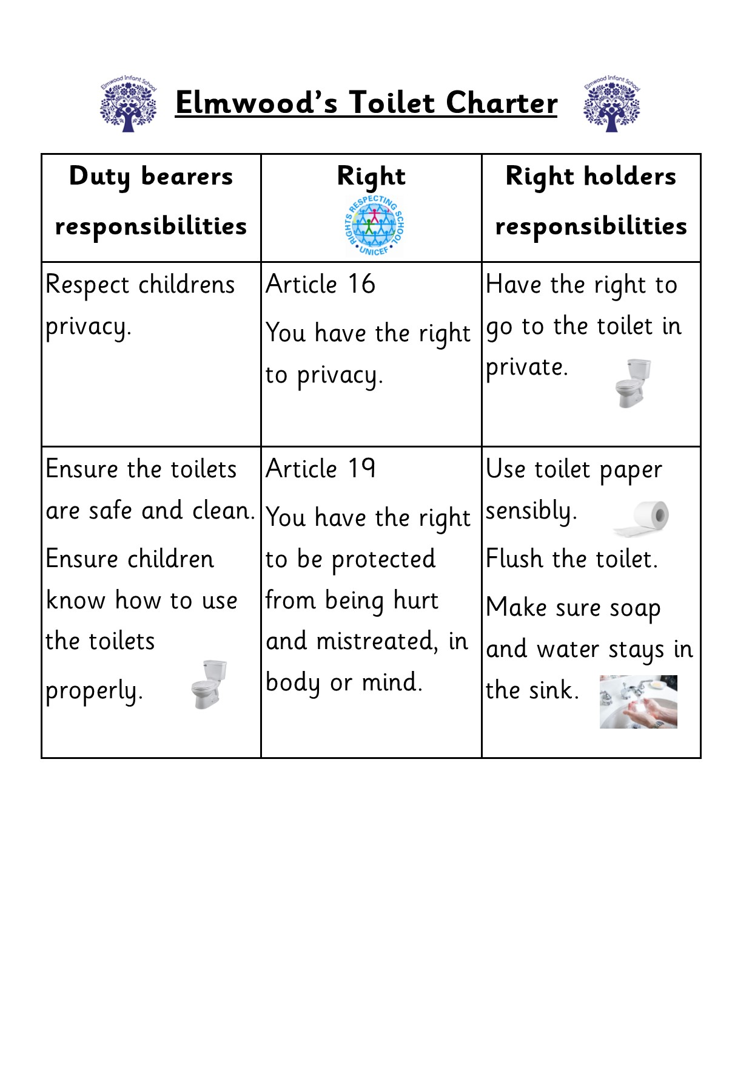

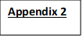

PHYSICAL INTERVENTION RECORD FORM
For reporting significant incidents where staff have had to physically restrain a pupil.

Details of pupil on whom physical intervention was used – name, class, and any SEN, disability or other vulnerability
Date, time and location of incident
Description of incident by the staff involved, including any attempts to de-escalate and warnings given that force might be used
Reason for physical intervention and description of what intervention/method used
Any injury suffered by staff or pupils and any first aid and/or medical attention required
Follow-up, including post-incident support and any disciplinary action against pupils
Any information and incident shared with staff no involved in it and external agencies
When and how those with parental responsibility were informed about the incident and any views they have expressed
Has any complaint been lodged (details should not be recorded)? Y/N
Names of staff involved (directly or as witnesses)
Details of other pupils involved (directly or as witnesses), including whether any of the pupils involved were vulnerable for SEN, disability, medical or social reasons

Report compiled by:
Role:
Date:
Report countersigned by:
Role:
Date:

The member of staff involved in the incident should compile the record. The member of staff with lead responsibility for safeguarding checks the record, signs it and uploads it onto CPOMs.

If there is an injury to the pupil or member of staff the school’s accident report form must be used (forms available from the school office).

